**9) How to visualise the traffic in instance group using Load Balancing ?**

Step 1 : Create an instance template with following details

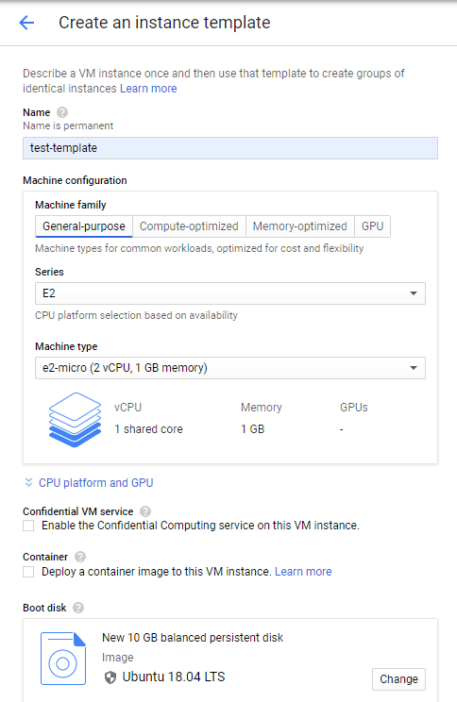

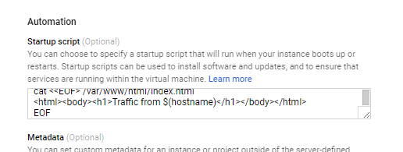

Startup script :

#! /bin/bash

apt-get update

apt-get install -y apache2

cat <<EOF > /var/www/html/index.html

<html><body><h1>Traffic from $(hostname)</h1></body></html>

EOF

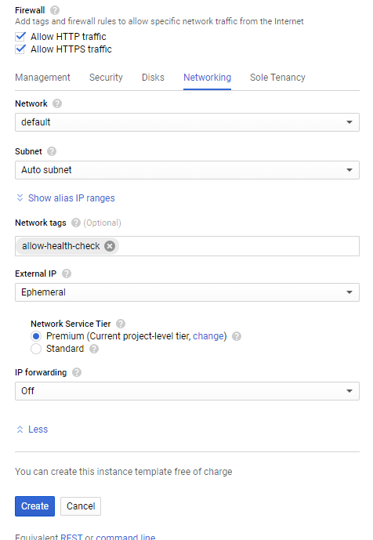

Step 2 : Create a new managed instance group with 2 instances

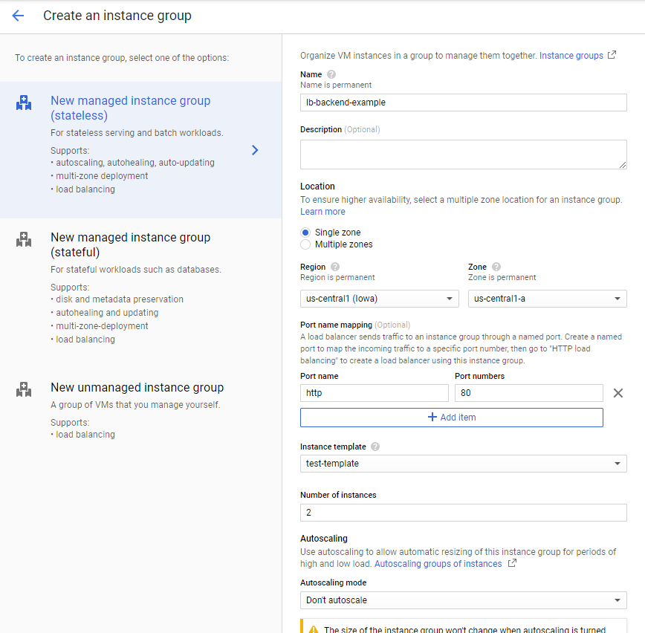

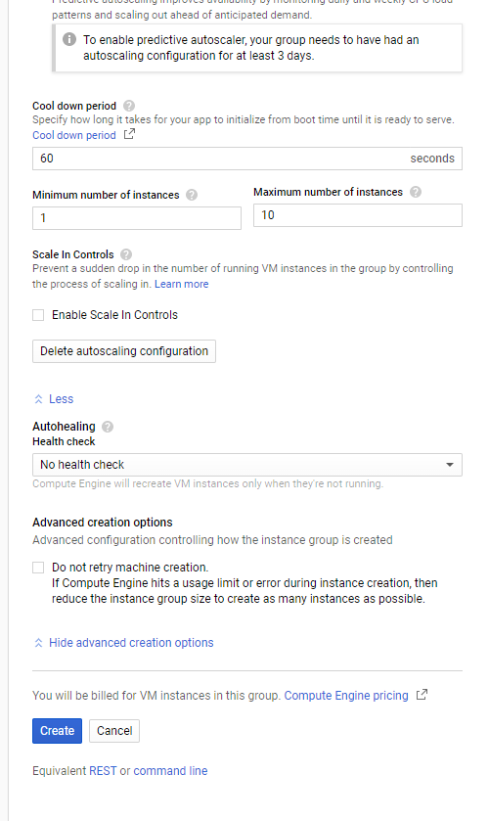

Create health check for instance group inorder to detect and automatically remove unhealthy VM instances.

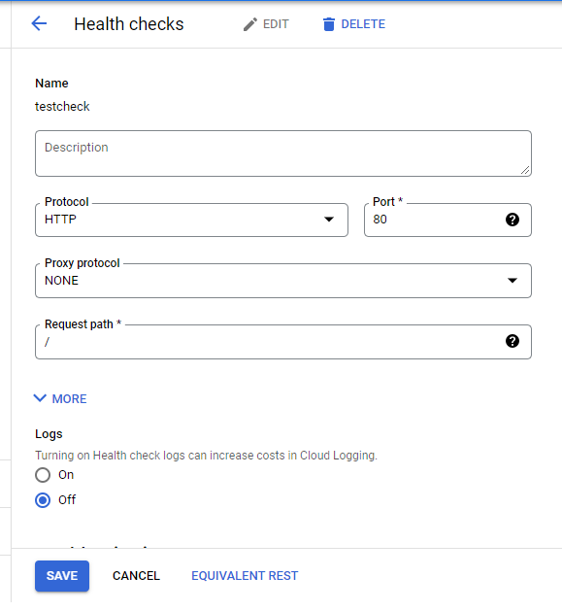

Step 3 : Created instance group

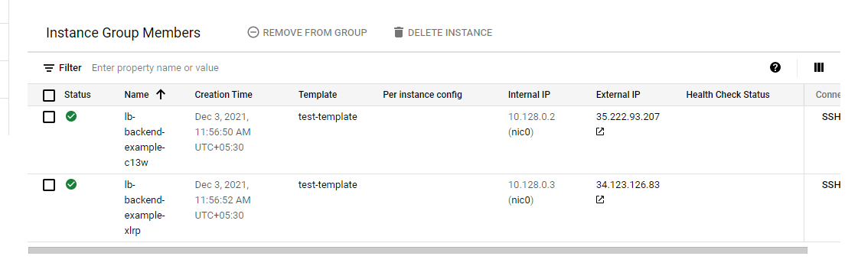

Step 4 : Set firewall rules for health-check

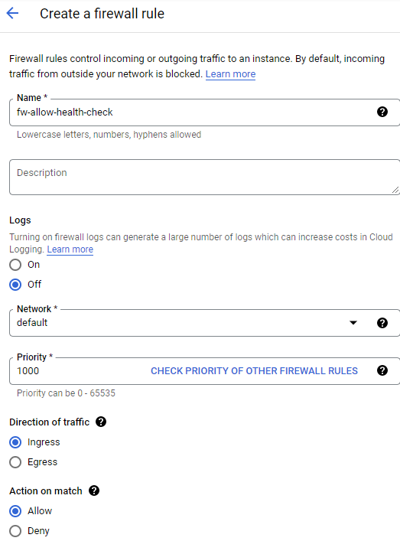

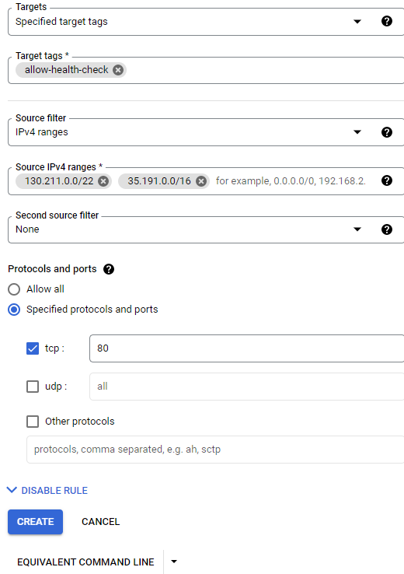

Step 5 : Reserve an external ip address

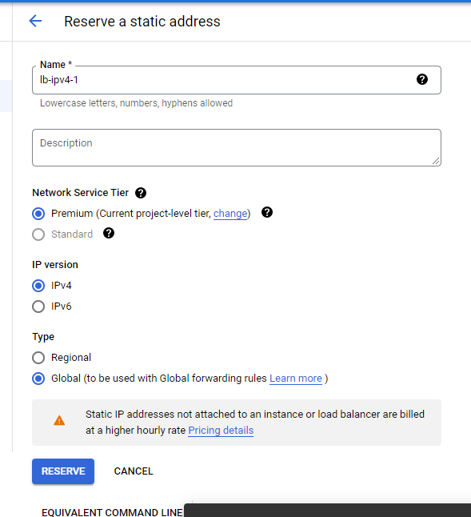

Step 6 : Now create a http load balancer

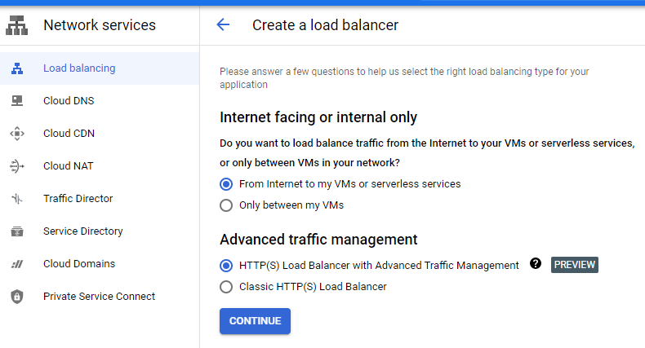

Step 7 : Fill up the Backend configuration as

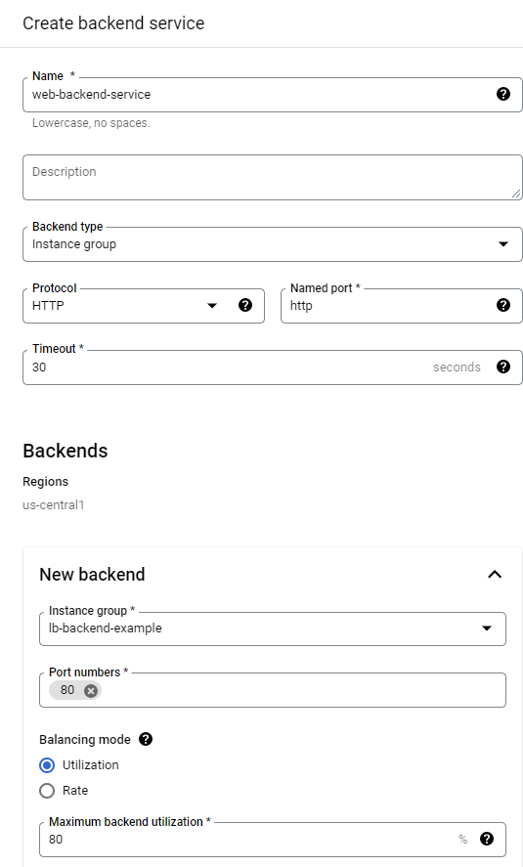

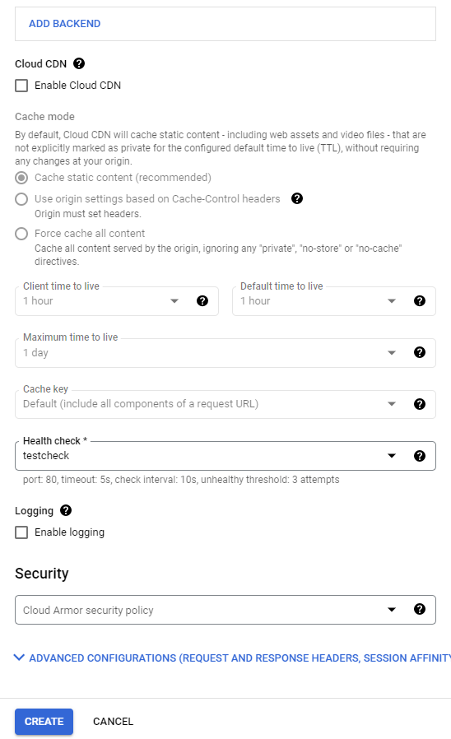

Step 8 : Fill up the front end configuration as

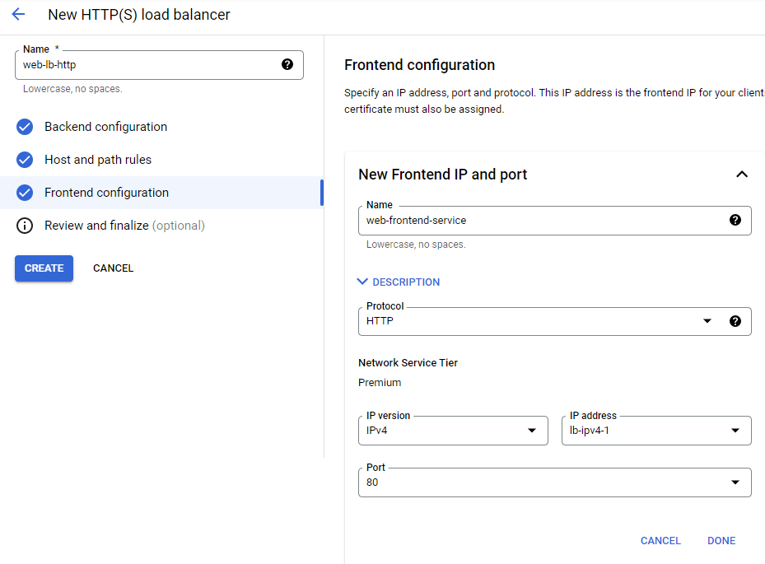

Step 9 : Review and finalize

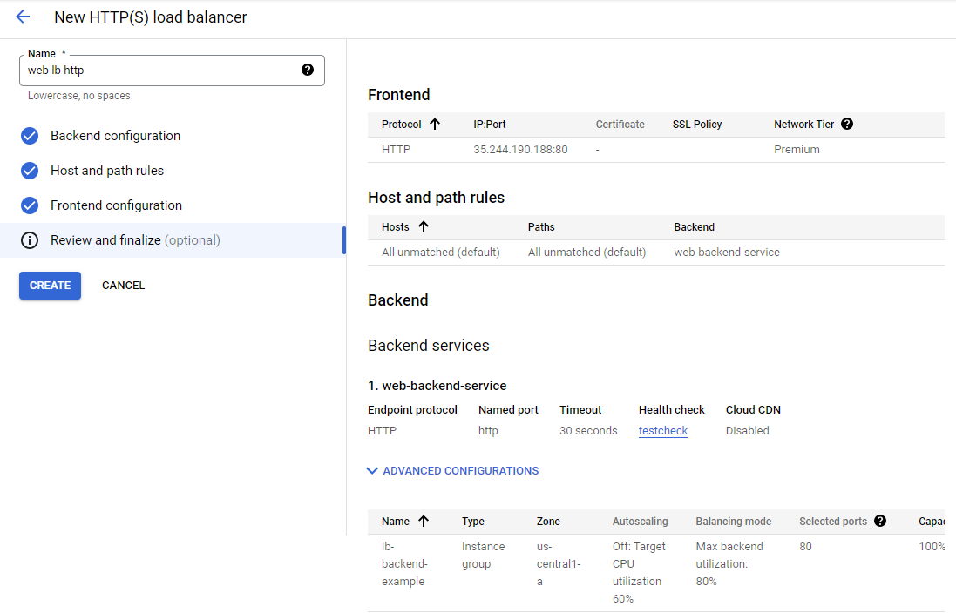

Step 10 : Load balancer created

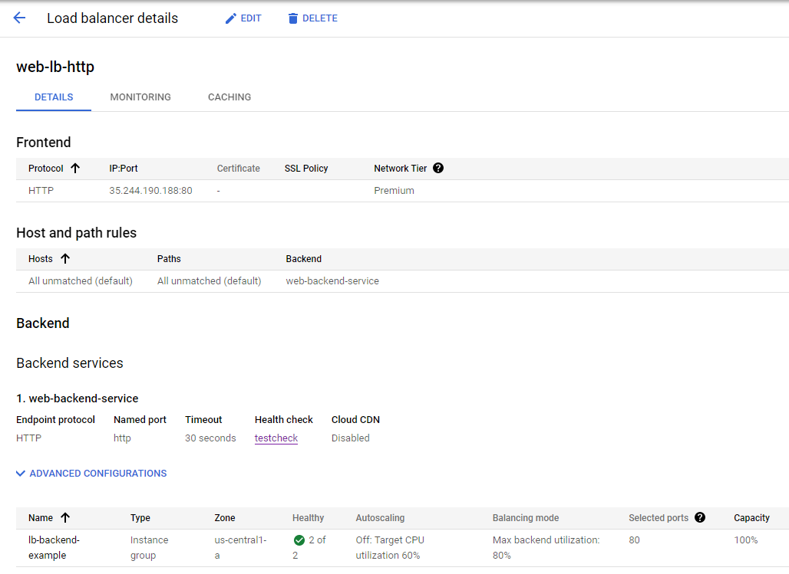

Step 11 : By browsing the IP:Port generated we get the traffic from instance group. Refreshing the site we can see theat traffic changes between two instances.

